# Diary Development Notes

Week 1

## Monday (7-Novmeber-2022)

* Explore the unit guideline and MS Team
* Find a company that I wish to join and contribute by filling up the google form providing by the unit chair.

Figure 1: Announcement from the unit chair related to the Company Selection

## Thursday (10-November-2022)

* Join the Week 1 Lecture Class

Week 2

## Monday (14-November-2022)

* Assign to Gopher Industry and work in the Team Avengers

## Tuesday (15-November-2022)

* Get familiarise with the team environment and review some of the previous document from T2 such as project handover document and video demonstration.

Figure 2: Welcome message from the Team Avengers and the Senior members

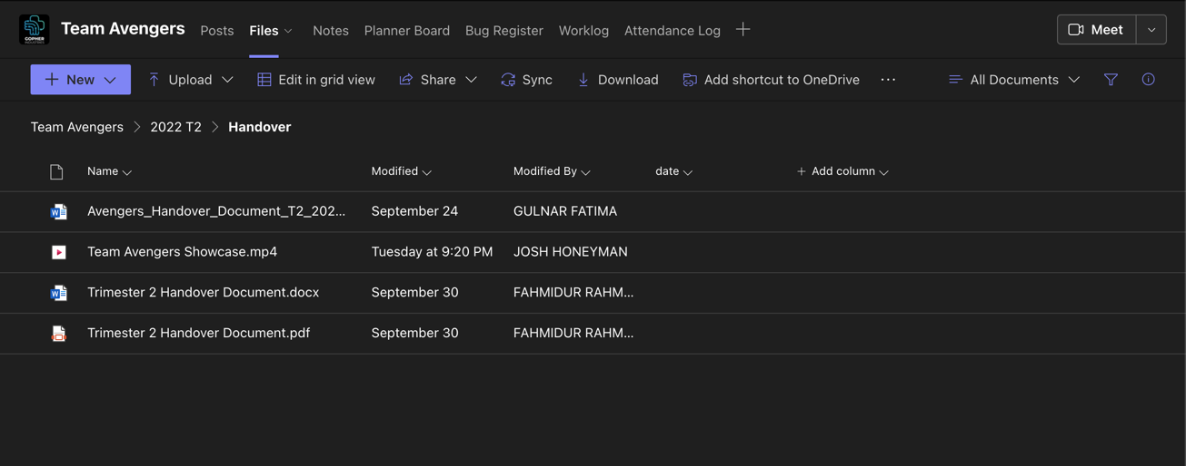

Figure 3: Handover document folder from previous trimester that I need to review

* Set up worklog and Attendance log by entering my student details

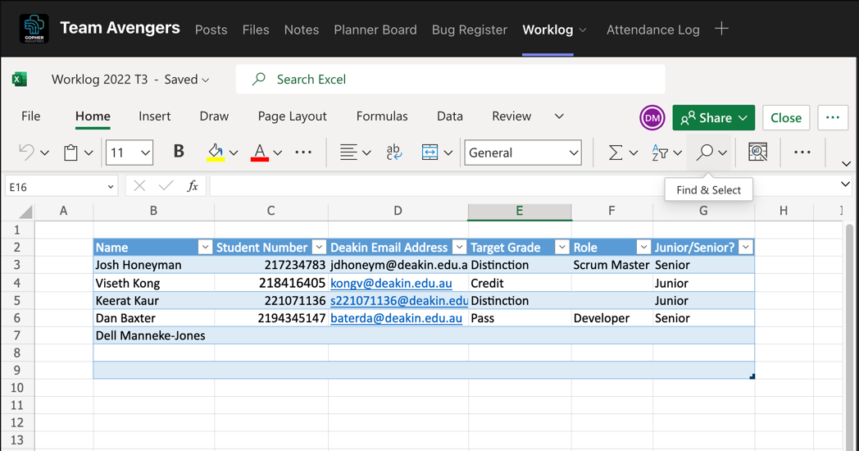

Figure 4: Our team worklog and attendance log for this trimester

## Wednesday (16-November-2022)

* Interact with Medi Chatbot on the test website <https://gopherindustries.webnode.page/>

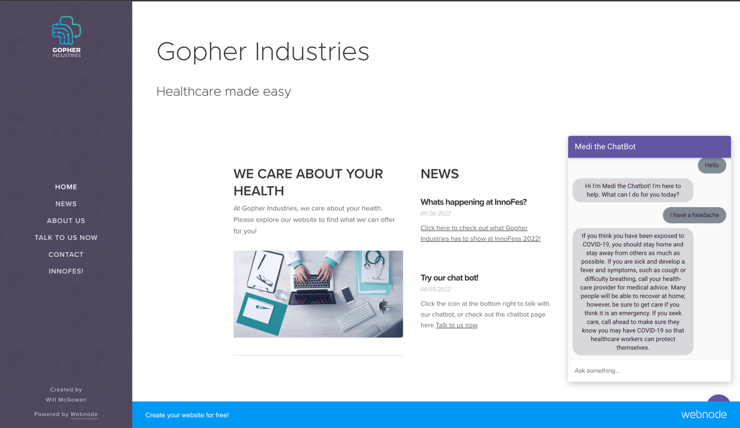

Figure 5: Testing the chatbot that were built from the previous team members

* Learning through the Google Developers course called Building Chatbots with Dialogflow recommended from the senior members

Figure 6: Learning how to build chatbots with Dialog

Figure 7: Testing my first Chatbot on Web Demo

* Complete task 1.1p and 2.1c

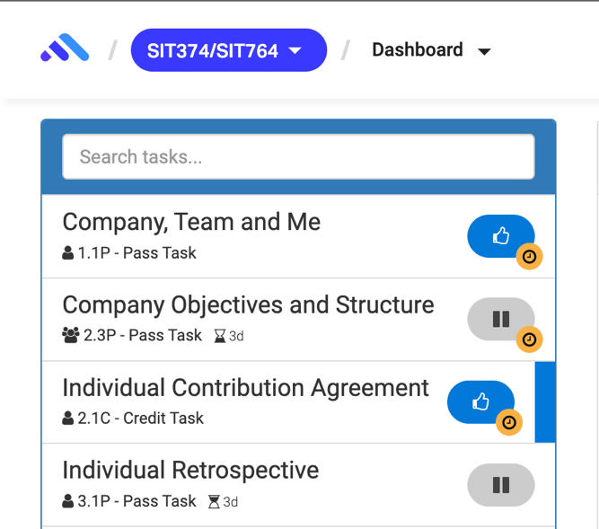

Figure 8: Submit tasks on Ontrack

## Thursday (17-November-2022)

* Join the Week 2 Lecture Class
* Join Surviving Capstone Meeting - Tips and Tricks from a Capstone Senior

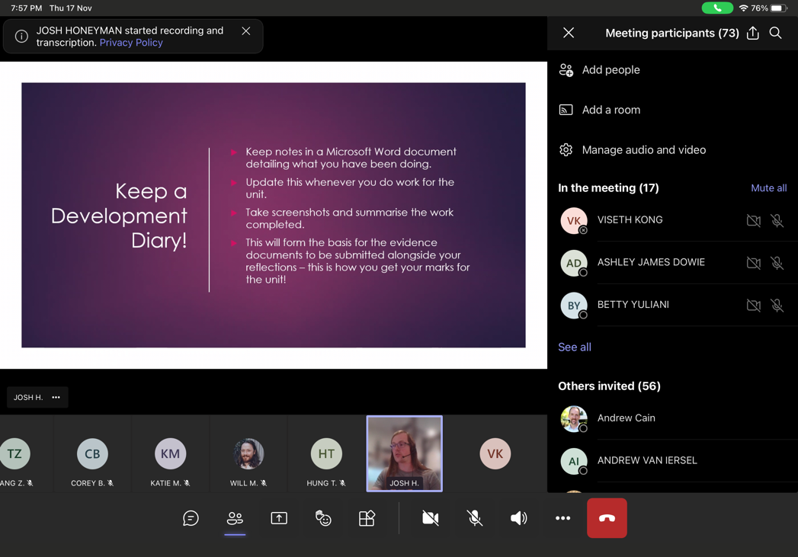

Figure 9: Meeting with Gopher Company

* Reply to senior member related to the meeting appointment issues

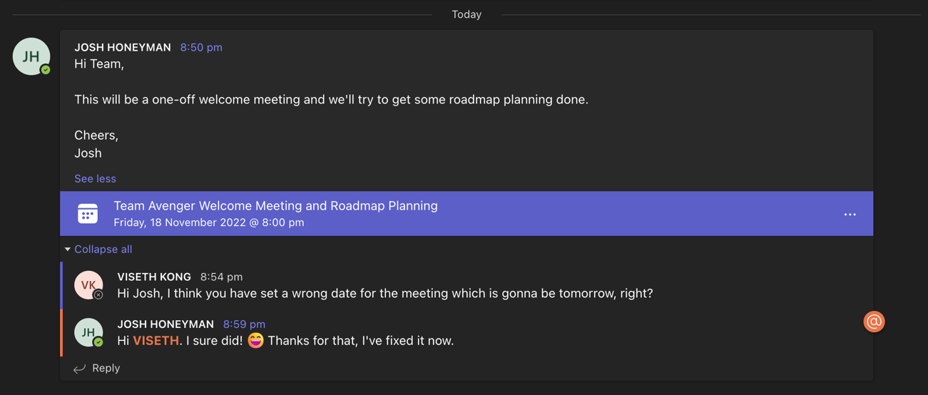

Figure 10: Reminded Josh when he set a wrong date for the meeting

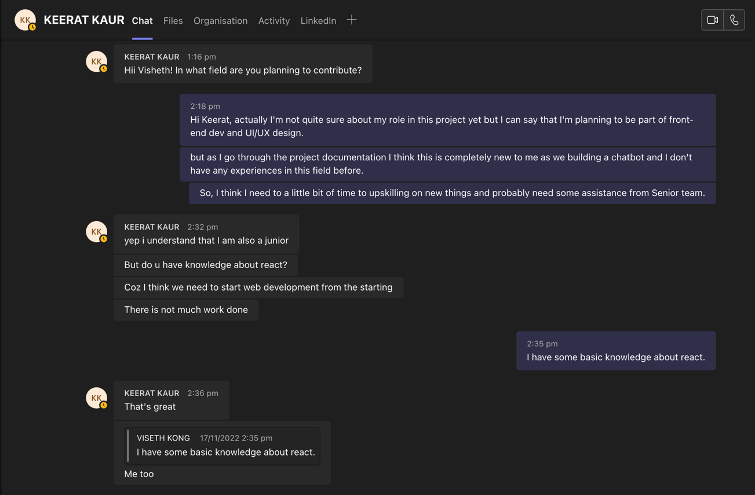

Figure 11: Have some conversation with other junior member about the role in the project

## Friday (18-November-2022)

* Continue learning through the Google Developers course called Building Chatbots with Dialogflow

Figure 12: Integrate a Dialogflow Chatbot with Actions on Google

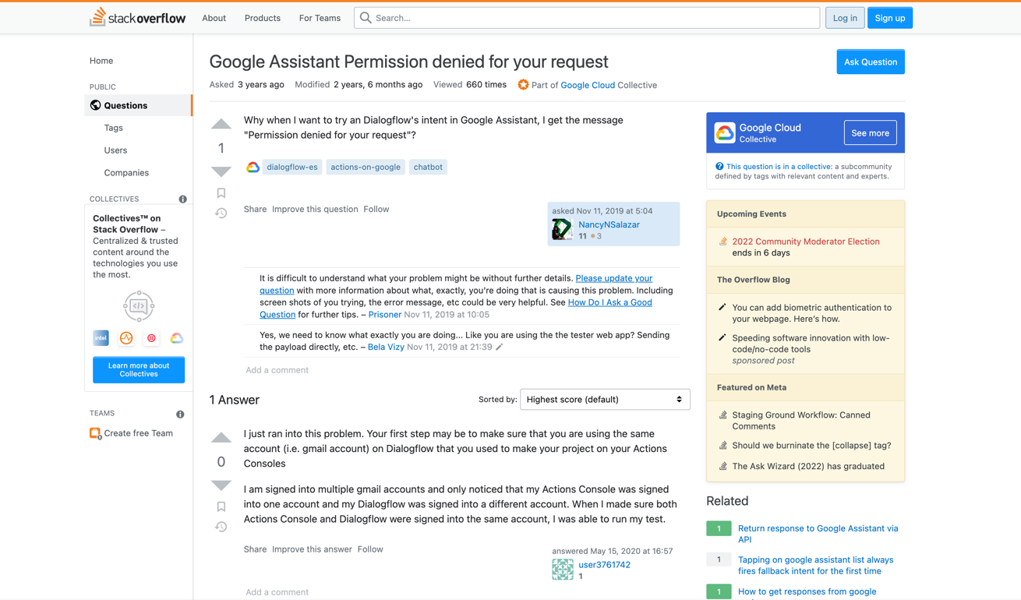

Figure 13: During my upskilling, I have encounter some issues and solve them successfully

* Research and found some essential resources related to the project

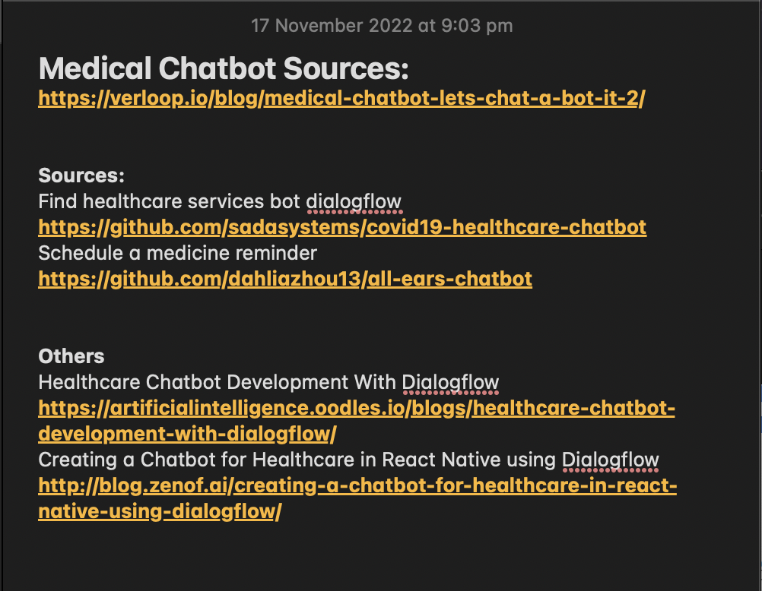

Figure 14: Some resources I found in google which related to my project

## Saturday (19-November-2022)

* Completed Ontrack task 1.1P and 2.1C

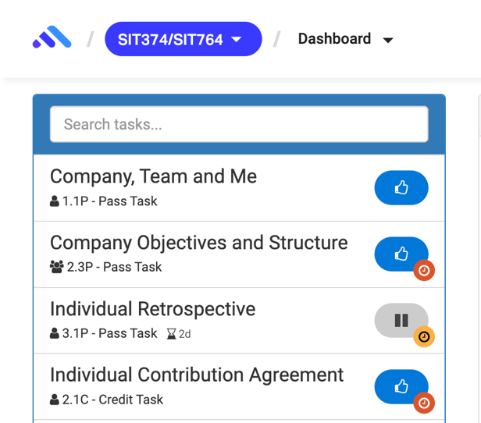

Figure 15: Ontrack Submission

Week 3

## Monday (21-November-2022)

* Join Sprint planning Meeting with Team Avengers.
* Learn how to use GitHub and Git command to clone, add, commit and push.

Figure 16: Git Command Notes

* Research on how to stream audio input to a detect intent request using the API.
* Read through the Github project related to speak-to-text function: <https://github.com/dialogflow/selfservicekiosk-audio-streaming/>
* Testing speak-to-text demo from the Github project: <http://selfservicedesk.appspot.com/>
* Link to article resources:
  + <https://cloud.google.com/dialogflow/es/docs/how/detect-intent-stream>
  + <https://cloud.google.com/dialogflow/es/docs/how/detect-intent-tts>
  + <https://princekfrancis.medium.com/dialogflow-detect-intent-with-streaming-from-mic-and-output-as-streaming-into-speaker-88b4166fca43>

## Tuesday (22-November-2022)

* Learn Node.Js fundamental through YouTube and various website.
* Learn how to use Google Cloud console and Google SDK to create credential and enable service account.

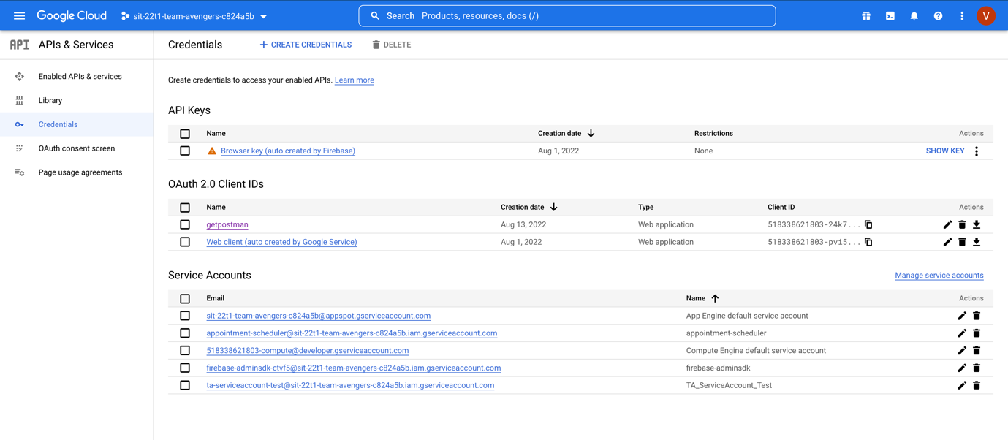

Figure 17: Google cloud console with Team avengers project to use DialogFlow

* Continue my research on audio input to a detect intent
* Join Daily Scrum meeting with Team Avengers
* Share a few resources that I have found with the team

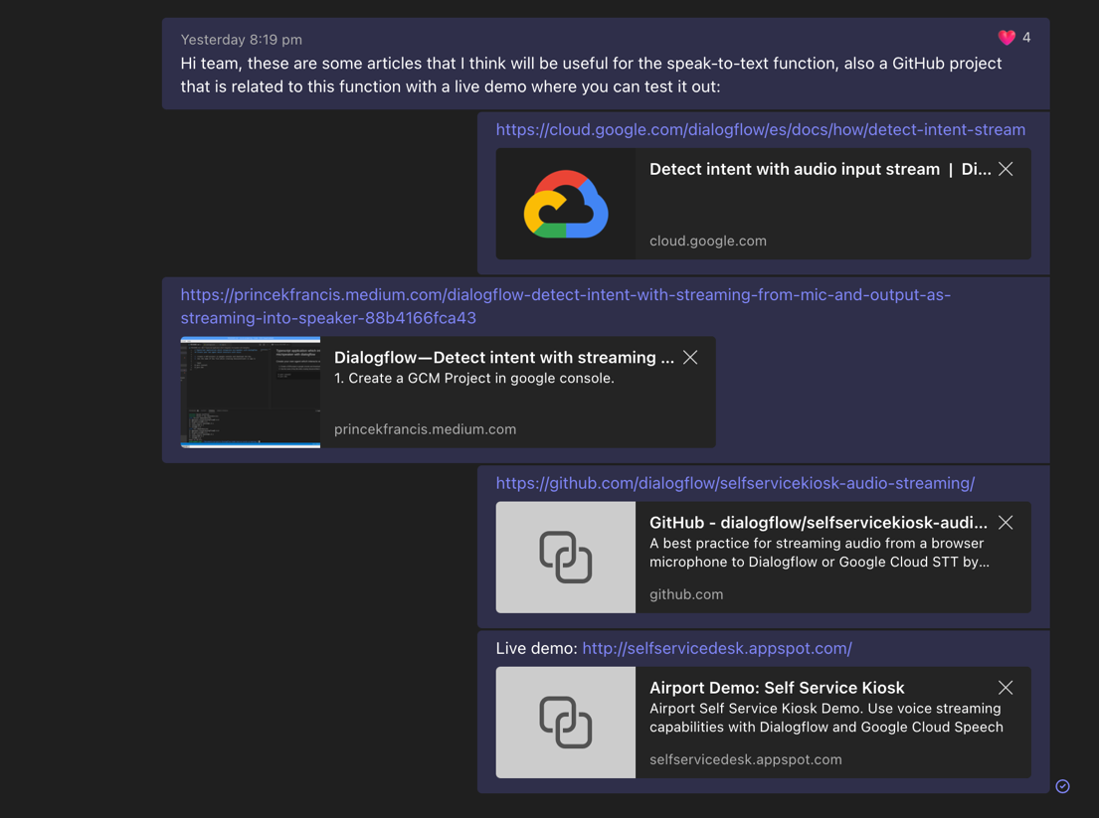

Figure 18: Share resources in the group chat

## Wednesday (23-11-2022)

* Join a meeting with the Project X team member (Nathan) regarding to the chatbot and company website integration.

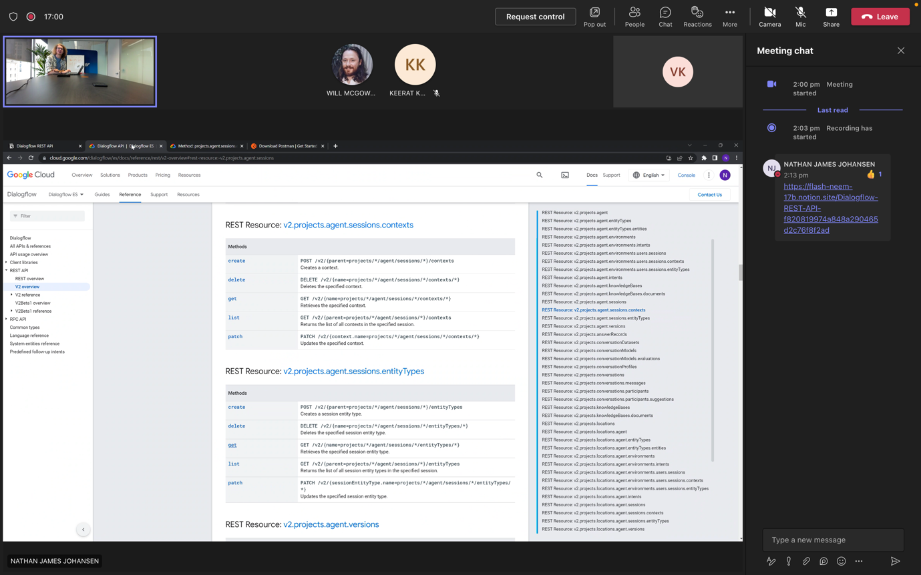

Figure 19: Meeting with Nathan from Team Project X

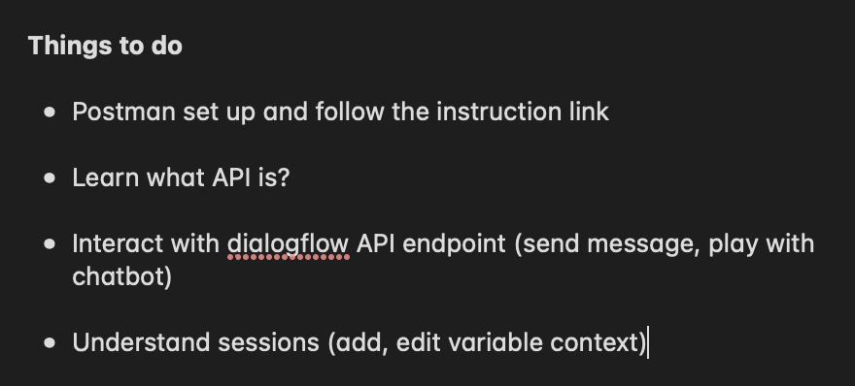

Figure 20: Notes on things I need to work on during the meeting with Nathan

* Join another meeting with Keerat (Junior student) regard to the assigned task and have some conversation regarding to the role

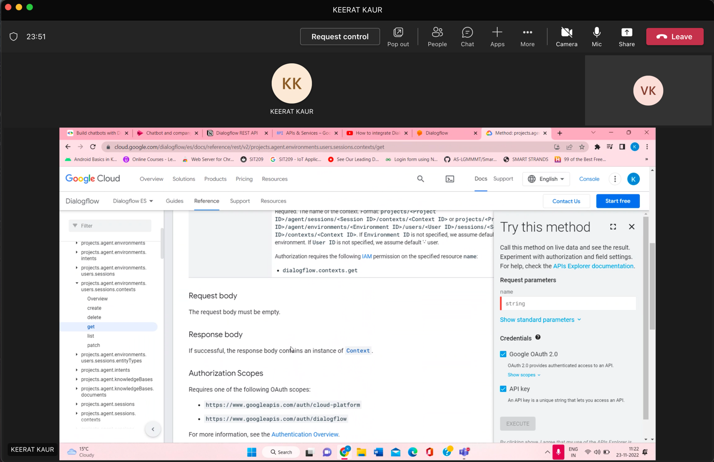

Figure 21: Meeting with Keerat about the assigned task

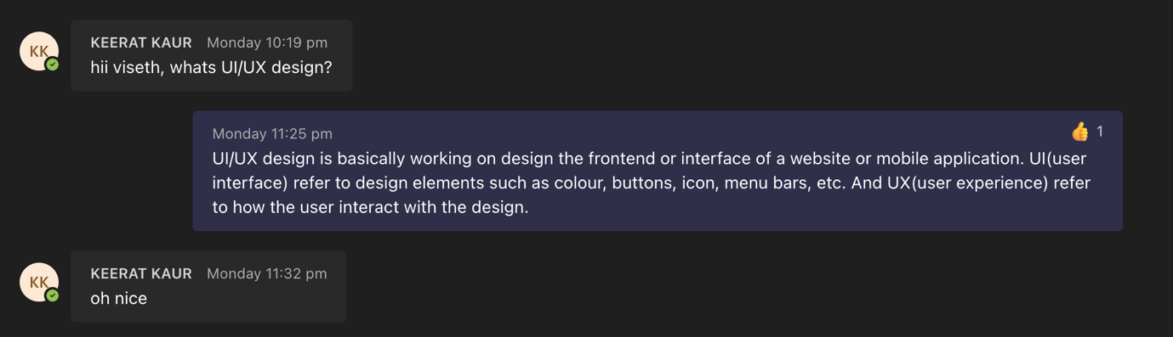

Figure 22: Have some conversations with Keerat

* Working on Dialogflow REST API by connect it with Postman but with my personal project

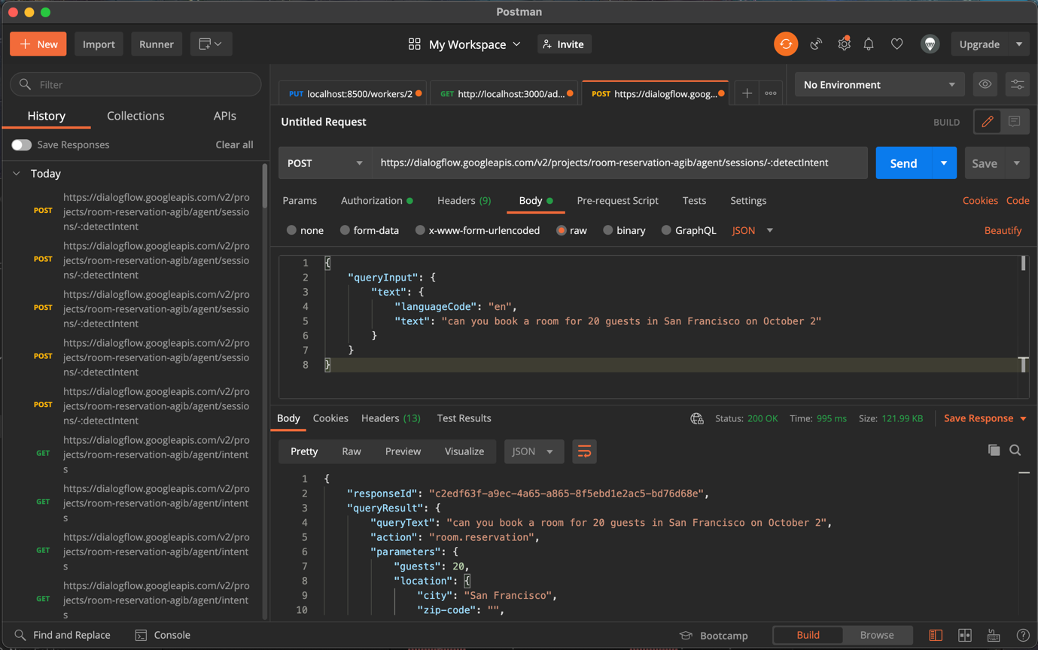

Figure 11: Connect DialogFlow API to Postman to and able to send queries

* Research on Integrating A Dialogflow Agent Into A Web Application: <https://www.smashingmagazine.com/2021/01/dialogflow-agent-react-application/>

## Thursday (24-11-2022)